NAME: AKSHAYA A
REG NO: 192421222
COURSE: CSA1402 COMPILER DESIGN

1. 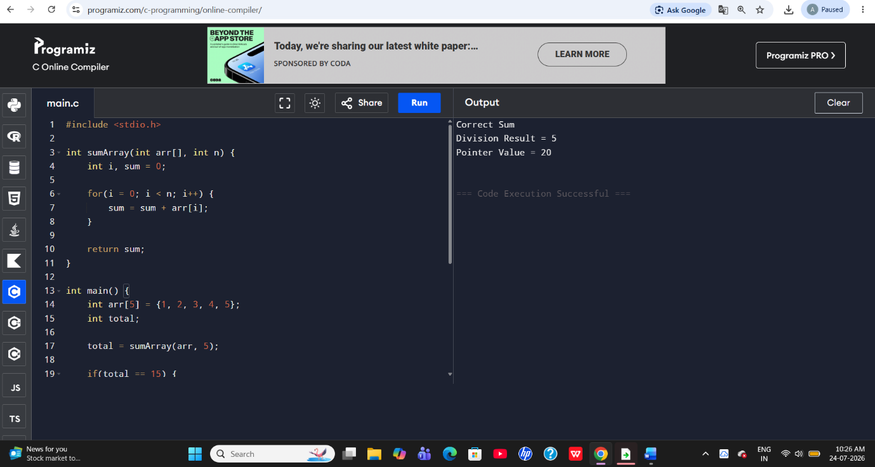

2.
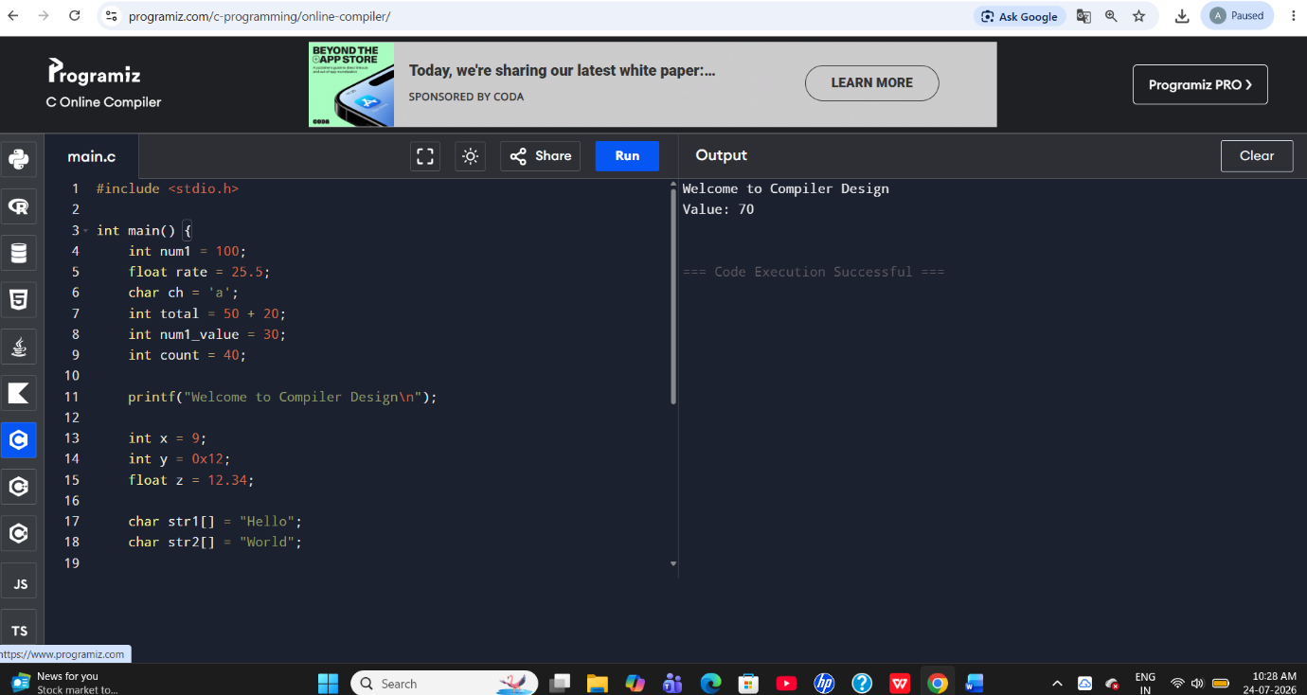

3.
